AIMS of the model
AUDIENCE

The system need to be modeled for the major of the city of Libertiville.

ISSUE

The Issue that the model need to address is to see if a bid need to be placed to bring a big online retailer in the city. Bringing the online retailed in the city will have both positive and negative effect on the city, and the model need to address if the benefit will be greater than the negative effects.

- Will allowing the online retailer to build a company improve the financial situation of the city?
- Will allowing the online retailer to build on the park, a staple for the community for over 50 years, create too much discontent among the citizens?
- Will it be worth for the city to allow the online retailed to build his next company in the city?

MESSAGE

The message that the user should receive from the model is to know if allowing the online retailed to build his company in the city, will have a good or bad impact on the finance of the city and the satisfaction of the citizens, and by how much.

- The presence of the new company in the city will be a great step for improving the finance of the city, allowing the city to attract more citizens, increasing the tax income of the city, and allowing to cancel the supposed cut of 10% of teachers in the school.

STORYLINE

The analysis should be presented to the user showing an output containing the following information:
- How much the building of the company in the city will improve the finance of the city
- How much the building of the company will affect the satisfaction of the citizens.

The User will then have to compare those results to the possible outcomes of not letting the company build the company and decide the best course of action.

MODEL STATEMENT

URBANIZATION AS CATALYST OF ECONOMICAL GROWTH
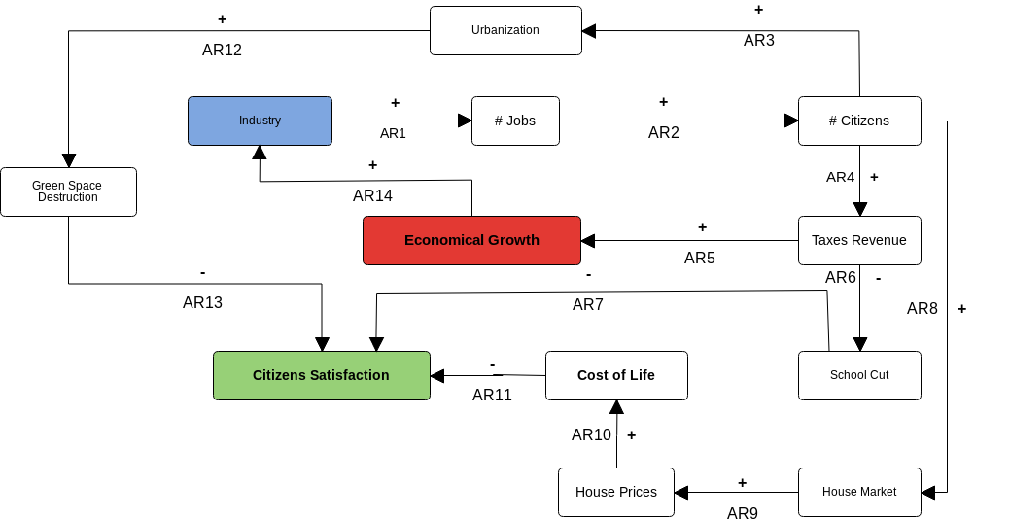
MODEL

GLOSSARY

AR1 = Increasing the number of industries will lead to a an increasing number of jobs available
AR2 = An increasing number of jobs available, will lead people to transfer in the city
AR3 = An increasing number of citizens in the city will lead to a process of urbanization of the city, to try to satisfy the necessities of all the workers
AR4 = An increasing number of citizens in the city will lead to and increase of the total income that the city receive from taxes
AR5 = An increased revenue from taxes will lead to the economical growth of the city
AR6 = An Increased revenue from taxes will allow the city to have enough money to reduce the planned cuts to the number of teachers in the school
AR7 = An Increased number of cut to the number of teacher in the school will result in a decreasing satisfaction of the citizens
AR8 = An increasing number of citizens in the city will lead to a greater number of people trying to search for a place to live
AR9 = An Increase of the number of people searching for houses will lead to a spike in the cost of houses, in relation to the supply and demand model
AR10 = An increase in the cost of the houses will lead to a higher cost of life
AR11 = A higher cost of life will lead to a decrease in citizen satisfaction
AR12 = The urbanization process will transform an increasing number of rural areas to urban areas, decreasing the number of green spaces available in the city
AR13 = A decreased number of green spaces will lead to a decrease in citizens satisfaction
AR14 = An economical growth will allow the city to offer significant incentives when placing a bid for a new company.This will lead to more companies establishing a new building in Libertiville

Confirmation Number: 75d88a6d-4785-494a-ab35-483a79999995

